Phase 1: Four-Centre Deployment | Kerala Statewide Expansion | April 2026 | Confidential

1. Purpose
Most people in Kerala who need Lakeshore never get there. Not because Lakeshore lacks the capability — it has it in abundance — but because the distance, the unfamiliarity, and the absence of a trusted first contact keeps patients in their district, managing conditions at facilities that cannot fully address them. By the time they do reach Kochi, many are later-stage, higher-acuity, and harder to treat.
The Distributed Healthcare Network (DHCN) is Lakeshore's response to this. It extends the hospital's clinical reach into the communities that make up its natural catchment — Ernakulam's eastern suburbs, Thrissur district, and the Malabar coast in Phase 1 — through two complementary node types. A
Health Pod at each location gives any resident a first point of contact with the Lakeshore system: a nurse, a Medical Officer, a structured assessment, and a clear onward pathway. A Satellite Clinic brings visiting Lakeshore specialists into the community on a regular schedule, so that patients who need cardiological, oncological, neurological, or orthopaedic care can access that care close to home.
The network carries Lakeshore's clinical standards into each catchment. Protocols, EMR, referral pathways, and quality benchmarks are the same at every node as they are on the main campus.

2. Two Node Types

 | Satellite Clinic | Health Pod
What it is | A branded Lakeshore floor or wing in a partner hospital. Lakeshore staff, protocols, and EMR. The community gets consistent, specialist-led care without travelling to Kochi. | A structured assessment and wellness station. Any resident can walk in and be seen by a nurse and Medical Officer, have their health evaluated, and leave with a clear plan.
Clinical offering | Multispecialty OPD by visiting Lakeshore consultants on weekly / fortnightly rotations. | NCD risk assessment, cardiovascular and metabolic profiling, structured disease detection across common conditions, lifestyle and preventive counselling.
Staffing | Node care coordinator (scheduling, EMR, care continuity). Visiting Lakeshore specialists. Partner hospital admin and billing. | Health Pod team: Programme Manager, community health worker, Medical Officer. Node nurse where co-located with satellite.
Partner relationship | Partner hospital provides the space. Lakeshore provides clinical brand, staff, protocols, and the referral pathway to Kochi. Revenue from shared diagnostic and referral activity is split under a formal MOU. | Partner hospital hosts the pod. Lakeshore runs it. Investigations that the partner's own facilities can conduct are done locally; those requiring Kochi-level infrastructure are transferred with full clinical handover.

3. Health Pod — Services and Operations
The Health Pod is the first point of contact between Lakeshore and the community. It is staffed by a nurse and a Medical Officer, operates within the partner hospital, and is open to any resident — whether they have a specific concern, have come in with a family member, or simply want to know where they stand with their health. Every visit generates a structured clinical record in the VPS EMR, creating continuity of care from the first encounter.
The pod serves people across the life course: adults managing chronic conditions, those with symptoms they have been putting off investigating, people with a family history of serious illness who want a baseline assessment, and well individuals seeking preventive guidance. Referrals come from the partner hospital's own outpatient flow, from community camps, and from Lakeshore's internal departments — consultants at Kochi routinely direct family members of patients toward the nearest pod for assessment.

3.1 Assessment and detection services
Assessment | Method at Health Pod | Finding → Onward Pathway
Cardiovascular and metabolic risk | Blood pressure, blood glucose, BMI, lifestyle history | Lifestyle counselling and monitoring for low-risk. Referral to satellite OPD (cardiology / general medicine) or Kochi for further workup where indicated.
Oral disease detection | Nurse-led clinical visual examination and palpation | Suspected lesion → biopsy at Kochi (surgical oncology / head and neck). Pre-cancerous change → monitored and treated.
Breast assessment | Clinical breast examination. Mammogram / ultrasound arranged for further evaluation. | Lump or suspicious change → guided biopsy at Kochi. Familial risk → genetic counselling and surveillance pathway.
Cervical health | HPV test. Vaccination offered where appropriate. | Abnormal finding → colposcopy and biopsy at Kochi (gynaecological oncology).
Colorectal assessment | Symptom history and faecal immunochemical test where indicated. | Positive or symptomatic → colonoscopy at Kochi (gastroenterology).
Respiratory and lung health | Symptom history, smoking history, breathlessness assessment. | Significant symptom burden or high-risk profile → low-dose CT chest. Referral to pulmonology / surgical oncology at Kochi.
Genomic and hereditary risk | Structured family history questionnaire. Flags hereditary disease predisposition. | Hereditary risk identified → genomic testing (BRCA, Lynch panel and others) and genetic counselling through Lakeshore Kochi genomics pathway.
Prostate health | PSA test for males over 50 or on clinical indication. | Elevated PSA → MRI prostate and urology referral at Kochi.

3.2 Counselling, prevention, and continuity
At every pod visit: lifestyle counselling covering tobacco, alcohol, diet, and physical activity; HPV vaccination; personalised health summary issued to the patient and recorded in VPS EMR. Care continuity: every patient seen at the pod has a longitudinal record in the Lakeshore system. Follow-up is managed by the node coordinator and contact centre. Patients with ongoing conditions are tracked between visits. Ongoing care after treatment: patients who have completed treatment at Lakeshore or elsewhere can use the pod for structured follow-up. Supportive services — physiotherapy, dietetics, speech and swallowing therapy, psycho-oncology, pain management — are coordinated from Kochi and brought to nodes as demand warrants. Community outreach: the pod team runs regular camps in schools, residential complexes, workplaces, and community institutions — bringing the same structured assessment to people who would not otherwise present to a health facility.

3.3 Physical layout
The Health Pod is a modular unit installed within a partner hospital lobby or a dedicated room allocated under the node MOU. It divides into three functional zones:

Zone | Function | Equipment
Experience Zone | Open area for NCD measurements and initial health assessment. First point of contact for all attendees. | Weighing scale, BP monitor ×2, glucometer, height measure, assessment questionnaire terminal or tablet.
Examination Room | Enclosed, private clinical area for breast and cervical examination. | Examination couch, privacy curtain, hand basin, oral examination kit, breast examination kit.
Information Desk | Counselling, risk score communication, EMR entry, investigation referral booking, follow-up scheduling. | EMR terminal, printer, 2 patient chairs, Lakeshore-branded desk, display screen for wellness content.

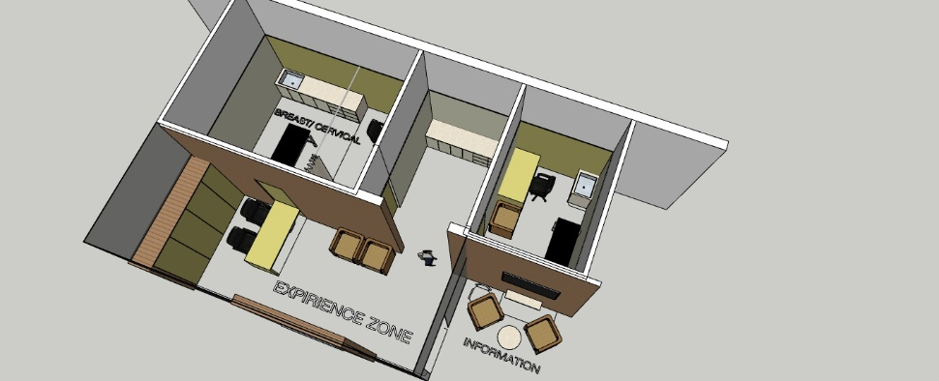
Figure 1 — Health Pod floor plan: Experience Zone, Examination Room, Information Desk
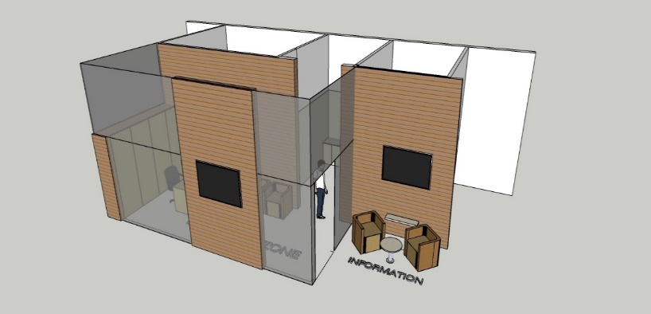
Figure 2 — Health Pod 3D render. See Annexure for dimensioned architectural drawings.

3.4 Infrastructure cost per Health Pod unit
Item | Est. Cost | Notes
Fit-out / partition works (within partner hospital space) | ₹1.5–3.0L | Depends on existing room condition. Modular partition system.
Examination couch, privacy screen, hand basin | ₹0.4L | Standard clinical furniture. Per examination room.
Assessment equipment — BP monitors, BMI scale, glucometer, oral and breast examination kit | ₹0.3L | BP apparatus, weighing machine, glucometer strips, torch, gloves, collection kits. Consumables recurring.
Information desk, seating, signage / branding | ₹0.4L | Lakeshore-branded desk fascia. 2 chairs for patient-facing counselling.
EMR terminal, printer, internet connectivity | ₹0.5–0.8L | VPS IT standard configuration. Full EMR integration across 3 partner hospital sites: ₹5–10L one-time capital, separate IT budget line.
IEC materials, display screen, initial collateral print run | ₹0.3L | Posters, banners, leaflets. Display screen for wellness content. Recurring print ~₹0.5L/yr per node.
TOTAL per Health Pod unit (fit-out + equipment) | ₹3.4–5.2L | Conservative ₹4L per unit as planning assumption. EMR integration capital is a separate IT budget line.

4. Satellite Clinic — Specialist Care in the Community
The satellite clinic brings Lakeshore's consulting specialists into each node on a fixed schedule. A patient in Kothamangalam who needs a cardiologist, a neurologist, or an orthopaedic surgeon can now see one within their district rather than making the journey to Kochi for an initial consultation. The visit happens in a familiar setting, at a Lakeshore-branded clinical space within the partner hospital, with the node coordinator managing the appointment, the EMR record, and any onward arrangement.
Where the condition requires surgery, a procedure, radiation, or admission — things that require Kochi-level infrastructure — the referral is managed seamlessly. The patient arrives at Lakeshore Kochi already known to the system: their history is in the EMR, their pre-authorisation is done, and their care team at Kochi has been briefed. After treatment, follow-up returns to the node. The satellite clinic keeps the community connected to Lakeshore across the full care episode — from first consultation through treatment and into long-term management. Consulting rooms (6–8) are provided by the partner hospital under the node MOU.

4.1 Specialty mix
Specialty | Why in the community | What is managed at the node | What requires Kochi | Frequency
Cardiology | Hypertension, IHD, and heart failure are the dominant conditions in Kerala's ageing population. Most patients manage these without ever seeing a cardiologist. A node clinic changes that. | Consultation, ECG, echo interpretation, risk stratification, medication review, pre-procedure workup. | PTCA, coronary angiography, CABG, structural heart interventions. | Weekly
Oncology | Patients with a diagnosis or a concerning finding should not have to make multiple Kochi trips before beginning care. The node clinic closes that gap. | Oncology consultation, treatment planning, oral chemotherapy initiation, systemic therapy follow-up. | Surgery, radiation, IV chemotherapy, BMT. | Weekly
Gastroenterology | GI disease, liver disease, and chronic gut conditions are common and chronically under-managed in district settings. Early specialist input changes outcomes. | GI consultation, IBD and GERD management, nutrition counselling, endoscopy planning, cirrhosis monitoring. | Colonoscopy, ERCP, liver biopsy, transplant workup. | Fortnightly
Orthopaedics | Joint pain and musculoskeletal conditions reduce quality of life for years before patients seek specialist care. A local clinic brings the decision forward. | MSK assessment, joint examination, physiotherapy direction, pre-operative evaluation, post-op review. | Knee and hip replacement, spine surgery, sports reconstruction. | Weekly
Neurology | Stroke survivors, epilepsy patients, and those with Parkinson's or neuropathic conditions need regular specialist review. Most do not get it in their district. | Neurological consultation, epilepsy and stroke follow-up, Parkinson's management, neuropathy assessment. | Stroke intervention, neurosurgery, complex neurodiagnostics. | Fortnightly
General Medicine | On-site daily. The generalist is the anchor of care continuity — managing chronic conditions, triaging new presentations, and coordinating onward pathways. | Chronic disease management across diabetes, hypertension, thyroid, respiratory, and renal conditions. Acute presentations. Gateway to visiting specialists. | Complex workup, procedures, and admissions that exceed the node's capability. | Daily

Nephrology and OBG are added at each node as patient demand establishes itself. Nephrology brings structured CKD management and transplant workup into the community. OBG addresses the substantial maternal and women's health needs at the Kothamangalam and Kunnamkulam catchments, with complex cases managed at Kochi.

5. Phase 1 — Four-Centre Deployment
# | Centre | District | Distance | Node Type and Launch
1 | VPS Lakeshore Kochi | Ernakulam | Origin | Health Pod pilot. July 2026 — pod live, protocols and EMR validated for rollout.
2 | MBMMH Kothamangalam | Ernakulam East | ~50 km | Satellite Clinic + Health Pod. August 2026. Node nursing team already in place.
3 | Malankara Mission, Kunnamkulam | Thrissur | ~75 km | Satellite Clinic + Health Pod. September 2026. Thrissur district entry. Node nurse in place.
4 | VPS Lakeshore Calicut | Kozhikode | ~200 km | Satellite Clinic + Health Pod. Sep–Oct 2026. Malabar hub. North Kerala catchment; outreach into Malappuram. PET-CT and mammogram available via BMH Kozhikode MoU.

The Health Pod activates first at each centre — it requires minimal infrastructure and can open within weeks of the MOU being signed. The satellite clinic follows 4–8 weeks later, once the visiting consultant schedule is confirmed. Community camps run from the first week, taking the pod's assessment services directly into schools, residential complexes, workplaces, and local institutions across the catchment. MBMMH and Malankara Mission bring established local patient relationships and in-house diagnostic capability; investigations that can be done at the partner hospital are done there, and those requiring Lakeshore-level infrastructure come to Kochi with a full clinical handover.

6. Catchment Activation — Community Outreach
Each DHCN node is supported by a structured outreach programme that takes health services directly into the communities within its catchment. The Health Pod and Satellite Clinic operate from fixed locations; the outreach programme reaches people who do not present to health facilities — those in rural pockets, underserved localities, and communities where health-seeking behaviour is low. Outreach is the demand-generation mechanism for the fixed nodes and an independent access pathway in its own right.

6.1 Programme formats
Format | Description | Scope and team
Mobile Medical Unit (MMU) | A vehicle-based clinical unit that operates a scheduled circuit across defined localities within each node's catchment. Runs a fixed weekly or fortnightly route with published stop times, enabling communities to plan attendance. | General physician, GNM nurse, community health worker, driver. Equipment: BP, glucometer, BMI, ECG, basic diagnostics, EMR terminal. Serves remote localities where fixed-site attendance is low.
Stationary Camp | Planned health camps at a fixed community venue — school, panchayath hall, mosque or temple, residential complex, workplace or factory. Announced in advance. Full pod assessment services delivered on-site for the camp duration. | 2 doctors, 2 GNM nurses, 2–3 community health workers, 1 marketing / coordination staff. Full assessment services. Duration: half-day (3–4 hours) or full-day (6 hours) depending on expected footfall.

6.2 Target locations and cadence
Priority locations for outreach within each catchment:

Location type | Rationale
Panchayaths and local self-government bodies | Widest community reach. Panchayath health programmes have established community trust. Partner for camp logistics and announcements.
Kudumbasree units and women's groups | High female attendance; directly relevant for breast and cervical health assessments. Existing network infrastructure for mobilisation.
Schools and colleges | Adolescent and young adult health. Staff and parents are secondary audiences. Oral health and lifestyle counselling priority.
Mosques and temples | Post-prayer assembly points with high regular footfall. Senior citizen populations well-represented. Effective for NCD and general health camps.
Residential complexes and gated communities | High-compliance, health-literate populations. Emergency response tie-ups possible alongside camps.
Workplaces, factories, and industrial estates | Organised captive populations. Employer coordination enables full-day camps. Occupational health angle relevant for industrial catchments (Kothamangalam, Calicut).

Target cadence from Phase 1 launch: minimum four camps per month per node catchment, scaling to six to eight per month by Q3 FY27 as the team and community relationships establish. MMU circuits run weekly from node launch. All camp and MMU encounters are recorded in the VPS EMR on the day. The contact centre follows up within 48 hours on all attendees with findings requiring further assessment.

6.3 Patient pathway from outreach to node
Outreach activity feeds the fixed nodes, not the other way around. An attendee at a camp or MMU stop who has a finding requiring further evaluation is given a booked appointment at the nearest Health Pod or Satellite Clinic before they leave. The encounter record is already in the EMR. The node coordinator is notified the same day. This closed-loop design ensures that outreach translates into ongoing care, not isolated one-time contact.

7. Startup Team
Name | Role | Transition | Node | Function
Prasanth CV | State Head Operations | 1 May 2026 | Kochi hub | DHCN Kerala operations lead. 25 yrs exp. B.Com, M.Com, PG Healthcare Mgmt.
Honey Devasia | Cluster Mgr — Health Pod Programme | 1 Apr 2026 | Mobile | Health Pod operations statewide. Programme manager linking outreach to pods. 15 yrs exp. BA, MSW.
Dr. Arya G Nair | Medical Officer | 1 Apr 2026 | Kochi / mobile | Clinical oversight at Health Pods. Reviews findings from pod assessments. Teleconsult for remote nodes. MPH, BDS.
Amala Minnu Sen | Community Health Worker | 1 Apr 2026 | Kochi / mobile | Patient counselling, health assessment communication, tobacco / alcohol brief intervention, camp coordination. MSW.
Anupama Aravindan | Senior Nurse | 1 May 2026 | Kothamangalam | Node nursing — Kothamangalam. GNM, 10 yrs exp.
Alphonsa Jacob | Sr. Nurse — Oncology | 1 May 2026 | Kothamangalam | Node oncology nursing — Kothamangalam. GNM, BSc Nursing, 10 yrs exp.
Ganga V S | Staff Nurse | 1 Apr 2026 | Kunnamkulam | Node nursing — Kunnamkulam. GNM, BSc Oncology Nursing.

Reporting: Health Pod team (Honey Devasia, Dr. Arya G Nair, Amala Minnu Sen) → DHCN Head / BD Head. Node operations stream (Prasanth CV, node nurses) → DHCN Head.

8. Financial Sustainability — FY 2026-27
The DHCN is designed to be self-sustaining from Year 1. The figures below align with the FY27 Annual Operating Plan (Initiative R-04, ₹13 Crore target). The full-year target requires the complete network — 10 satellite clinics and 25 Health Pods — to be progressively deployed across FY27, with Phase 1 (four centres) forming the Q2 starting tranche and Phase 2 nodes (six additional satellite clinics, 21 additional pods) launching from Q3 onwards.

Capital investment — one-time FY27
The capital requirement for the full network build-out is a one-time FY27 cost. This is not captured in the AOP initiative register (which records opex only) and should be included in the hospital's FY27 capex budget separately.

Item | Unit cost | Units | Total
Health Pod fit-out + equipment (10 nodes, full network) | ₹4.0L | 10 | ₹40L
Satellite OPD consulting room fit-out (9 partner hospital nodes) | ₹5.0L | 9 | ₹45L
EMR terminal integration per partner hospital site | ₹7.5L | 9 | ₹67.5L
Branding, signage, IEC materials across all nodes | ₹1.0L | 10 | ₹10L
Outreach camp and MMU equipment pool | ₹2.0L | 4 | ₹8L
TOTAL CAPEX — FULL NETWORK |  |  | ~₹170L
of which: Phase 1 (4 centres, FY27 Q1–Q2) |  |  | ~₹60L
of which: Phase 2 (6 additional nodes, FY27 Q3–Q4) |  |  | ~₹110L

Annual operating cost — FY27 (AOP-aligned)
The AOP register records ₹65L/yr opex for R-04. This covers the node team and core programme operations. Outreach camp logistics (MMU running costs, camp consumables, IEC materials) of approximately ₹12L/yr are budgeted under R-09 (Scaled BD Organisation), which carries the broader community outreach programme. Consultant travel is absorbed in departmental operating budgets.

Item | Annual cost
DHCN team — 7 transitioning staff (node nursing, Health Pod programme, community health) | ₹46.6L
Node operations: consumables, admin, IT AMC, legal (MOU maintenance) | ~₹10.4L
Consultant travel (visiting specialists to partner nodes) | ~₹8.0L
TOTAL ANNUAL OPEX — R-04 (per AOP) | ₹65L
Outreach camp logistics (budgeted under R-09) | ~₹12L separately

Network income — FY27 (AOP quarterly phasing)
Income phasing below is drawn directly from the AOP P&L monthly model for R-04. Q1 is the setup and MOU phase. Income begins in Q2 as Phase 1 nodes activate and builds through Q3 and Q4 as Phase 2 nodes come online.

Quarter | Gross income | Nodes active | Cumulative | Activity basis
Q1 FY27 (Apr–Jun) | ₹0 | 0 | ₹0 | MOU signing, infrastructure setup, team onboarding. No patient activity.
Q2 FY27 (Jul–Sep) | ₹141.8L | 2–4 | ₹141.8L | Kochi pod live Jul. Kothamangalam Aug. Kunnamkulam Sep. 5 pods active. First satellite clinic OPDs running.
Q3 FY27 (Oct–Dec) | ₹472.7L | 8–10 | ₹614.5L | Calicut node Oct. Phase 2 nodes activating: 4 new satellite clinics + 5 new pods across Q3. Ramp building.
Q4 FY27 (Jan–Mar) | ₹685.5L | 10 + 25 | ₹1,300L | Full network of 10 satellite clinics + 25 Health Pods at or approaching steady state. Monthly run-rate ₹236L by Feb–Mar.
FULL YEAR GROSS — FY27 | ₹1,300L |  | ₹13.0 Cr | Per AOP R-04 target. Weighted average across progressive ramp.
Less: annual opex (R-04) | (₹65L)
NET CONTRIBUTION — FY27 | ₹1,235L |  | ₹12.35 Cr | Capex of ~₹170L (full network) recovers within Q4 at run-rate income.

Phase 1 contribution (4 centres): The four Phase 1 centres account for approximately ₹340–360L of the ₹1,300L FY27 total, activating through Q2. The remaining ₹940–960L requires Phase 2 nodes (six additional satellite clinics, 21 additional pods) to launch progressively through Q3 and Q4 FY27. The Phase 2 node pipeline — Thrissur city, Muvattupuzha, Aluva, Perumbavoor, Thodupuzha, Palakkad, and additional pod-only sites — needs MOU activity to begin by June 2026 for Q3 activation to be achievable.

9. Implementation Roadmap
Phase | When | Milestone | Owner
Approval | Apr 2026 | Board / MD sign-off. Phase 1 capex (₹60L) and full-network capex (₹170L) to be included in FY27 capex budget. R-04 opex ₹65L/yr confirmed. Team reporting lines confirmed. | CEO
Team onboard | Apr–May 2026 | DHCN team transitions complete. | HR / Prasanth CV
MOUs | May 2026 | MOUs signed with MBMMH, Malankara Mission, VPS Calicut. Revenue share schedules agreed. | BD Head / CFO / Legal
Infrastructure | May–Jun 2026 | Health Pod units (₹4L × 4) procured and installed. EMR terminals (₹7.5L × 3) configured. Consulting rooms fitted out. Health assessment questionnaire live in HIS. Gastro / Urology / Gynaecology briefed on internal Health Pod referral programme. | IT / DHCN Ops
Training | Jun 2026 | Node team and Health Pod programme staff trained on VPS protocols, EMR, assessment and detection protocols, and investigation referral pathways. | CNO / DHCN Head
Kochi pilot | Jul 2026 | Health Pod live at Kochi campus. MMU circuit and first camp programme launched in Ernakulam. Kothamangalam OPD schedule confirmed. | Honey Devasia
Node launch | Aug–Oct 2026 | Kothamangalam, Kunnamkulam, Calicut nodes fully operational (Health Pod + Satellite Clinic OPD). MMU circuits running at all nodes. Monthly camp calendar active. | Prasanth CV
Phase 2 MOU pipeline | Jun 2026 | MOU discussions initiated with Phase 2 nodes: Thrissur city, Muvattupuzha, Aluva, Perumbavoor, Thodupuzha, Palakkad. Must be signed by Aug 2026 to enable Q3 FY27 activation. Phase 2 targets ₹940L of the ₹1,300L FY27 income. | BD Head / CFO
Phase 2 launch | Oct–Dec 2026 | Six additional satellite clinics + 21 additional pods progressively operational across Q3–Q4 FY27. Full network of 10 clinics + 25 pods at or approaching steady state by Jan 2027. | BD Head / Prasanth CV

Annexure — Health Pod: Architectural Layout Drawings
The drawings below show two layout options for the Health Pod, each in plan view with dimensions. These are reference drawings for the infrastructure and facilities team. Final configuration to be adapted to the available space at each node.

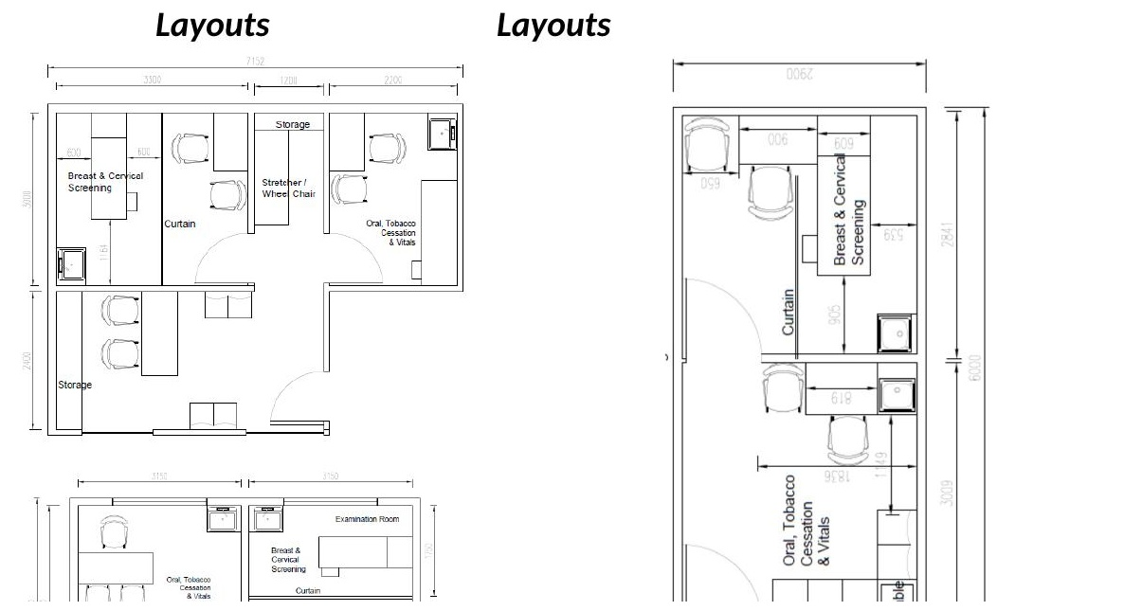

Layout Option A (upper left): Wider footprint (~7.15m × 5.0m). Three distinct zones — Breast & Cervical Screening room, central examination bay with curtain, Oral/Tobacco/Vitals area — with separate storage alcoves and stretcher/wheelchair bay. Suited to larger room allocations within the partner hospital.
Layout Option B (lower left): Compact footprint (~6.85m × 3.5m). Two-room arrangement — Examination Room and Breast/Cervical Screening — with a shared Oral/Tobacco/Cessation area and attendant seating. Suited to constrained corridor or alcove allocations.
Layout Option C (right): Narrow deep footprint (~2.9m × 8.0m). Single-corridor layout with Breast & Cervical Screening bay, curtained examination area, Oral/Tobacco/Cessation zone, and branding wall. Suited to repurposed corridor sections or single-room installations.

All layouts share a common zone logic: a clinical examination area (private, curtained), a wellness and vitals area (open), and an information / counselling point. Branding wall specified in each option for Lakeshore signage. Dimensions in millimetres. Detailed MEP, electrical, and finishes specifications to be developed by the facilities team based on the selected option for each node.
VPS Lakeshore Hospital · DHCN Blueprint Note · April 2026 · Confidential

